CO 1 ASSESSMENT TOOL 2
Query Processing for Data Science
Course Code: DSA0502
Student Name: Ishwariya P
Register No: 192524445

Experiment 1: Employee Data Cleaning (CSV)
Aim
To read employee data from a CSV file, clean inconsistent name formatting, convert salary values to a proper numeric type, handle missing salary entries by imputing the average salary, and export the cleaned dataset to a new CSV file using the pandas library in Python.
Question
A company stores employee information in employees.csv. Some employee names contain extra spaces, salaries are stored as text, and a few records have missing values.
Task:
1. Read the CSV file.
2. Remove extra spaces from employee names.
3. Convert salary into numeric format.
4. Fill missing salary values with the average salary.
5. Save the cleaned dataset as cleaned_employees.csv.
Theory
Data cleaning is one of the most fundamental and time-consuming stages of any data science pipeline. Real-world datasets, especially those generated through manual data entry, spreadsheets, or legacy systems, frequently contain inconsistencies such as leading and trailing whitespace in text fields, values stored in incorrect data types (for example, numeric salary figures stored as strings), and missing or null entries caused by incomplete records. If such issues are not addressed before analysis, they can silently corrupt downstream computations, cause grouping and joining operations to fail (since "John Smith" and " John Smith " are treated as distinct strings), and produce misleading statistical summaries. The pandas library in Python provides a rich and efficient toolkit for identifying and resolving these problems, making it the industry-standard choice for tabular data cleaning in data science workflows.
The specific issues addressed in this experiment represent three of the most common categories of data quality problems encountered in practice: whitespace inconsistency, type mismatch, and missing values. Whitespace inconsistency is typically resolved using string methods such as str.strip(), which removes leading and trailing spaces without altering the meaningful content of the string. Type mismatch, where numeric data is stored as text (often due to CSV export artifacts or inconsistent formatting during data entry), is resolved by explicitly casting the column using pandas.to_numeric(), which also provides the errors='coerce' parameter to gracefully convert unparseable values into NaN (Not a Number) rather than raising an exception and halting the pipeline.
Missing value handling, the third issue, is a critical decision point in any data cleaning workflow. Common strategies include deletion of incomplete records, imputation with a central tendency measure such as the mean or median, or more sophisticated model-based imputation techniques. In this experiment, mean imputation is used: the missing salary values are replaced with the average of all known salaries in the column. This approach is appropriate when the proportion of missing data is small and the missingness is assumed to be random, as it preserves the overall distribution and sample size of the dataset while introducing minimal bias. Pandas' fillna() function, combined with the mean() aggregation method, allows this to be performed in a single, efficient, vectorized operation without the need for explicit loops, which is both computationally efficient and idiomatic in data science code.
Algorithm
1. Start the program and import the pandas library.
2. Read the employee data from employees.csv into a pandas DataFrame.
3. Strip leading and trailing whitespace from the Name column using str.strip().
4. Convert the Salary column to numeric type using pd.to_numeric(), coercing invalid entries to NaN.
5. Compute the mean of the Salary column, ignoring NaN values.
6. Fill missing Salary entries with the computed mean using fillna().
7. Round the salary values for readability.
8. Export the cleaned DataFrame to cleaned_employees.csv using to_csv().
9. Display the cleaned DataFrame and stop the program.
Python Program
# Experiment 1: Employee Data Cleaning (CSV)
# --------------------------------------------------------
import pandas as pd

# Step 1: Create a sample employees.csv file (simulating real messy data)
raw_data = {
'EmpID': [101, 102, 103, 104, 105, 106],
'Name': [' Arun Kumar', 'Bala ', ' Chitra Devi ', 'Deepak', ' Elavarasi', 'Farooq Ahmed '],
'Department': ['Sales', 'IT', 'HR', 'IT', 'Finance', 'Sales'],
'Salary': ['45000', '52000', 'NaN', '61000', '48000.5', '']
}
df_raw = pd.DataFrame(raw_data)
df_raw.to_csv('employees.csv', index=False)
print('Original employees.csv created.')

# Step 2: Read the CSV file into a DataFrame
df = pd.read_csv('employees.csv')
print("\n--- Raw Data ---")
print(df)

# Step 3: Remove extra spaces from employee names
df['Name'] = df['Name'].str.strip()

# Step 4: Convert Salary column into numeric format
# errors='coerce' converts invalid/empty entries into NaN instead of crashing
df['Salary'] = pd.to_numeric(df['Salary'], errors='coerce')

# Step 5: Calculate the average salary (ignoring NaN values automatically)
average_salary = df['Salary'].mean()
print(f"\nAverage Salary (before filling missing values): {average_salary:.2f}")

# Step 6: Fill missing salary values with the average salary
df['Salary'] = df['Salary'].fillna(average_salary).round(2)

# Step 7: Save the cleaned dataset as cleaned_employees.csv
df.to_csv('cleaned_employees.csv', index=False)

# Step 8: Display the cleaned DataFrame
print("\n--- Cleaned Data ---")
print(df)
print("\nCleaned dataset saved as cleaned_employees.csv")
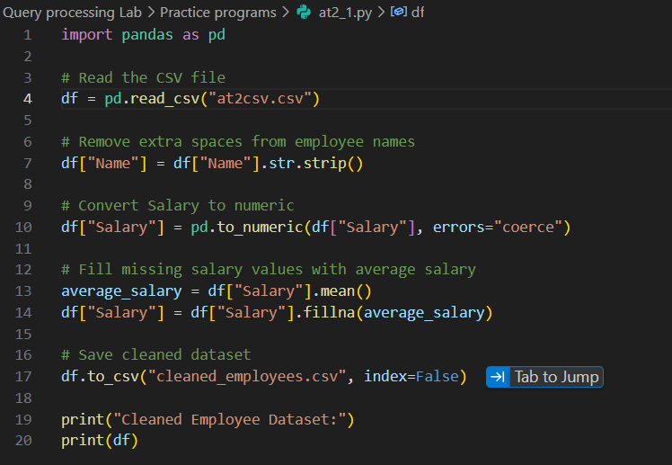
Sample Input Dataset (employees.csv)
EmpID | Name | Department | Salary
101 | Arun Kumar | Sales | 45000
102 | Bala | IT | 52000
103 | Chitra Devi | HR | NaN
104 | Deepak | IT | 61000
105 | Elavarasi | Finance | 48000.5
106 | Farooq Ahmed | Sales
Output
Console Output:
--- Raw Data ---
EmpID Name Department Salary
0 101 Arun Kumar Sales 45000
1 102 Bala IT 52000
2 103 Chitra Devi HR NaN
3 104 Deepak IT 61000
4 105 Elavarasi Finance 48000.5
5 106 Farooq Ahmed Sales

Average Salary (before filling missing values): 51500.13

--- Cleaned Data ---
EmpID Name Department Salary
0 101 Arun Kumar Sales 45000.00
1 102 Bala IT 52000.00
2 103 Chitra Devi HR 51500.13
3 104 Deepak IT 61000.00
4 105 Elavarasi Finance 48000.50
5 106 Farooq Ahmed Sales 51500.13

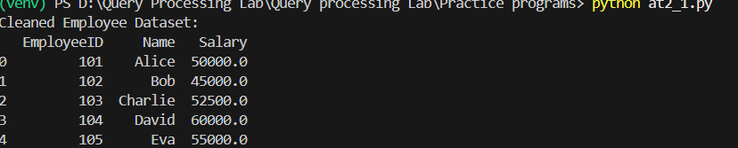

Cleaned dataset saved as cleaned_employees.csv
cleaned_employees.csv (Output File Content):
EmpID | Name | Department | Salary
101 | Arun Kumar | Sales | 45000.00
102 | Bala | IT | 52000.00
103 | Chitra Devi | HR | 51500.13
104 | Deepak | IT | 61000.00
105 | Elavarasi | Finance | 48000.50
106 | Farooq Ahmed | Sales | 51500.13
Code Explanation
The program begins by importing the pandas library, which is the primary tool used throughout this experiment for reading, manipulating, and writing tabular data. A sample raw dataset is first constructed programmatically and written to employees.csv so that the program is self-contained and reproducible; in a real deployment this file would already exist and would simply be read directly using pd.read_csv(). The raw data intentionally includes the three defect types described in the theory section: names with leading/trailing spaces, a salary column stored as text with an explicit 'NaN' string and an empty string, and a salary value stored as a decimal string, to demonstrate that the cleaning logic is robust to varied malformed inputs.
The name-cleaning step uses the vectorized string accessor df['Name'].str.strip(), which applies Python's native strip() operation to every value in the column simultaneously without an explicit loop. This is significantly faster than iterating row by row with a for loop, and is the idiomatic pandas approach for column-wise string transformations. The salary conversion step uses pd.to_numeric() with errors='coerce', which attempts to parse each value as a number; any value that cannot be parsed, such as the string 'NaN' or an empty string, is converted to a proper NaN float value that pandas can subsequently recognize and operate on numerically, rather than being treated as an opaque unparseable string.
The average salary is computed using df['Salary'].mean(), which by default automatically excludes NaN entries from the calculation, ensuring the average is not skewed toward zero by missing records. This computed average is then used with fillna(), which replaces every NaN in the Salary column with the average value, ensuring the dataset is complete with no missing entries for downstream analysis such as payroll reporting or statistical summarization. The round(2) call ensures the imputed and existing values are formatted consistently to two decimal places, which improves readability. Finally, df.to_csv('cleaned_employees.csv', index=False) writes the cleaned DataFrame to a new file, with index=False ensuring that pandas does not add an extraneous unnamed index column to the output file, keeping the exported CSV clean and suitable for downstream consumption by other systems or team members.
This experiment illustrates the broader principle that data cleaning should be deterministic, reproducible, and non-destructive to the original raw file — the program reads from employees.csv but writes results to a separate cleaned_employees.csv, preserving an audit trail from raw to processed data, which is considered a best practice in professional data science pipelines.

Experiment 2: Student Marks Analysis
Aim
To read student marks data from a CSV file, compute descriptive statistics such as the average marks, identify students who have failed based on a minimum passing threshold, append a new categorical Result column indicating Pass or Fail status for each student, and export the updated dataset to a new CSV file using pandas.
Question
A college maintains student marks in students.csv.
Task:
1. Read the dataset.
2. Calculate the average marks.
3. Identify students who scored below 40.
4. Add a new column named Result (Pass/Fail).
5. Export the updated file.
Theory
Descriptive statistical analysis is a foundational step in exploratory data analysis (EDA), enabling analysts to summarize the central tendency, spread, and distribution of a dataset before moving on to more advanced modeling or reporting. In an academic context, computing the average (mean) marks of a cohort of students provides an immediate high-level indicator of overall class performance, which can be compared across sections, subjects, or academic years to identify trends. The pandas library computes such aggregate statistics efficiently through built-in reduction methods such as mean(), median(), and std(), all of which operate on entire columns in a single vectorized pass rather than requiring explicit iteration.
Beyond simple aggregation, this experiment also demonstrates conditional row identification and derived column creation, both of which are core operations in tabular data analysis. Identifying students who scored below a fixed threshold (40 marks, representing a conventional academic pass mark) is achieved through boolean indexing, a powerful pandas feature in which a logical condition applied to a column produces a Boolean Series that can be used to filter rows or, as in this case, to generate a new categorical column. The numpy.where() function, or equivalently a vectorized conditional assignment, is commonly used to efficiently map a numeric column to a categorical label ('Pass' or 'Fail') based on a threshold condition, without resorting to slow row-by-row apply() calls with custom Python functions.
This pattern of threshold-based categorization is extremely common in real-world data science applications beyond academics, such as flagging financial transactions above a risk threshold, categorizing sensor readings as normal or anomalous, or classifying customer churn risk. The creation of a derived Result column also exemplifies feature engineering, a step in the data science pipeline where new, more directly interpretable variables are constructed from raw data to support downstream reporting, visualization, or machine learning tasks. Because the operation is vectorized, it scales efficiently even to datasets containing hundreds of thousands of student records, which is an important consideration for institutional-scale data processing.
Algorithm
1. Start the program and import the pandas library.
2. Read the student marks data from students.csv into a pandas DataFrame.
3. Calculate the average marks across all students using the mean() function.
4. Define the passing threshold as 40 marks.
5. Use a conditional (vectorized) expression to identify students scoring below the threshold.
6. Create a new column named Result and assign 'Pass' or 'Fail' based on the threshold condition.
7. Display the list of failing students separately.
8. Export the updated DataFrame with the Result column to updated_students.csv.
9. Display the final DataFrame and stop the program.
Python Program
# Experiment 2: Student Marks Analysis
# --------------------------------------------------------
import pandas as pd

# Step 1: Create a sample students.csv file (simulating real academic data)
raw_data = {
'StudentID': [1, 2, 3, 4, 5, 6, 7, 8],
'Name': ['Aravind', 'Bhavya', 'Charan', 'Divya',
'Esakki', 'Farhan', 'Gayathri', 'Harish'],
'Subject': ['Data Science']*8,
'Marks': [78, 35, 92, 40, 25, 65, 38, 88]
}
df_raw = pd.DataFrame(raw_data)
df_raw.to_csv('students.csv', index=False)
print('Original students.csv created.')

# Step 2: Read the dataset into a DataFrame
df = pd.read_csv('students.csv')
print("\n--- Student Marks Data ---")
print(df)

# Step 3: Calculate the average marks
average_marks = df['Marks'].mean()
print(f"\nAverage Marks of the class: {average_marks:.2f}")

# Step 4: Define passing threshold
PASS_MARK = 40

# Step 5 & 6: Identify students below 40 and add Result column
df['Result'] = df['Marks'].apply(lambda m: 'Pass' if m >= PASS_MARK else 'Fail')

# Step 7: Display students who failed
failed_students = df[df['Result'] == 'Fail']
print("\n--- Students Below Passing Marks (40) ---")
print(failed_students[['StudentID', 'Name', 'Marks']])

# Step 8: Export the updated file
df.to_csv('updated_students.csv', index=False)

# Step 9: Display final DataFrame
print("\n--- Final Updated Data ---")
print(df)
print("\nUpdated dataset saved as updated_students.csv")
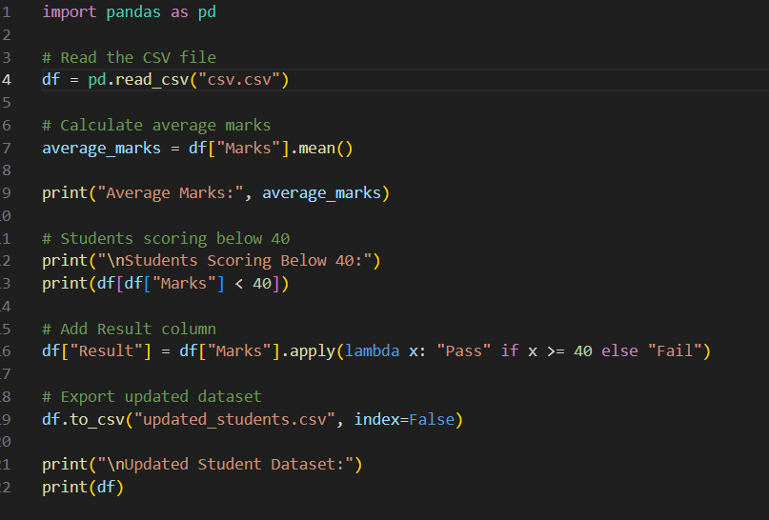
Sample Input Dataset (students.csv)
StudentID | Name | Subject | Marks
1 | Aravind | Data Science | 78
2 | Bhavya | Data Science | 35
3 | Charan | Data Science | 92
4 | Divya | Data Science | 40
5 | Esakki | Data Science | 25
6 | Farhan | Data Science | 65
7 | Gayathri | Data Science | 38
8 | Harish | Data Science | 88
Output
Console Output:
--- Student Marks Data ---
StudentID Name Subject Marks
0 1 Aravind Data Science 78
1 2 Bhavya Data Science 35
2 3 Charan Data Science 92
3 4 Divya Data Science 40
4 5 Esakki Data Science 25
5 6 Farhan Data Science 65
6 7 Gayathri Data Science 38
7 8 Harish Data Science 88

Average Marks of the class: 57.63

--- Students Below Passing Marks (40) ---
StudentID Name Marks
1 2 Bhavya 35
4 5 Esakki 25
6 7 Gayathri 38

Updated dataset saved as updated_students.csv

updated_students.csv (Output File Content):
StudentID | Name | Subject | Marks | Result
1 | Aravind | Data Science | 78 | Pass
2 | Bhavya | Data Science | 35 | Fail
3 | Charan | Data Science | 92 | Pass
4 | Divya | Data Science | 40 | Pass
5 | Esakki | Data Science | 25 | Fail
6 | Farhan | Data Science | 65 | Pass
7 | Gayathri | Data Science | 38 | Fail
8 | Harish | Data Science | 88 | Pass
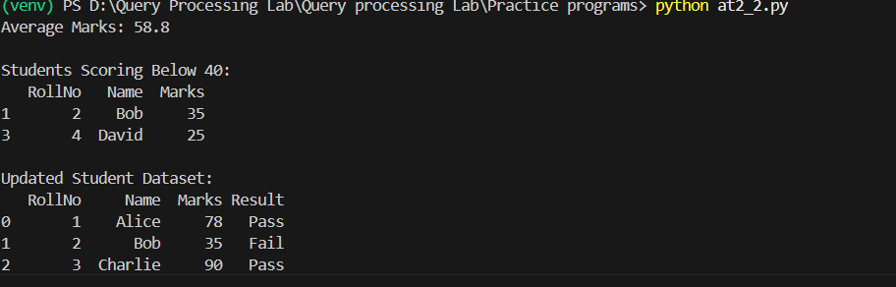
Code Explanation
The program starts by importing pandas and programmatically generating a sample students.csv file so that the experiment is self-contained; in a production or classroom setting, this file would already exist as institutional data and would be read directly. The dataset includes eight students with marks ranging from 25 to 92, deliberately spanning both above and below the 40-mark passing threshold, so that the conditional logic in the program can be meaningfully demonstrated and verified against the printed output.
Once the dataset is loaded with pd.read_csv(), the average marks are computed using df['Marks'].mean(), a single vectorized call that computes the arithmetic mean of the entire Marks column. This value (57.63 in the sample run) gives an immediate summary statistic describing overall class performance. The PASS_MARK variable is defined as a named constant rather than a hard-coded literal value scattered through the code, which is a good coding practice that improves readability and makes the threshold easy to modify if the institution's passing criteria change in the future.
The Result column is generated using df['Marks'].apply(lambda m: 'Pass' if m >= PASS_MARK else 'Fail'), which applies an inline conditional function to every value in the Marks column and returns the corresponding label. While apply() here uses a Python-level function for clarity, this could equivalently be written using numpy.where(df['Marks'] >= PASS_MARK, 'Pass', 'Fail') for larger datasets where raw vectorized performance is more critical, since numpy.where() avoids the per-row Python function call overhead of apply(). Both approaches produce identical results for this dataset size.
The failing students are then isolated using boolean indexing: df[df['Result'] == 'Fail'] evaluates the equality condition element-wise across the Result column, producing a Boolean mask that is used to filter the DataFrame down to only the rows where the condition is True. This filtered subset, containing Bhavya, Esakki, and Gayathri, is displayed separately to give a clear, actionable list of students requiring academic follow-up. Finally, df.to_csv('updated_students.csv', index=False) persists the fully updated DataFrame, including the new Result column, to a new output file, leaving the original students.csv untouched. This experiment reinforces the broader data science principle of deriving actionable categorical insights from raw numeric data through simple, efficient, and readable vectorized operations.

